SAPPY Application User Manual

1. **Objectives Achieved**

The main objective is to **reduce expenditure, increase profit & save time** through proper inventory management.

Cost Optimization

Order Frequency

Stocking Policy

Duplicate Items

Supplier Ranking

Supplier Data

Pareto graph

Consumption

# **Consumption:**

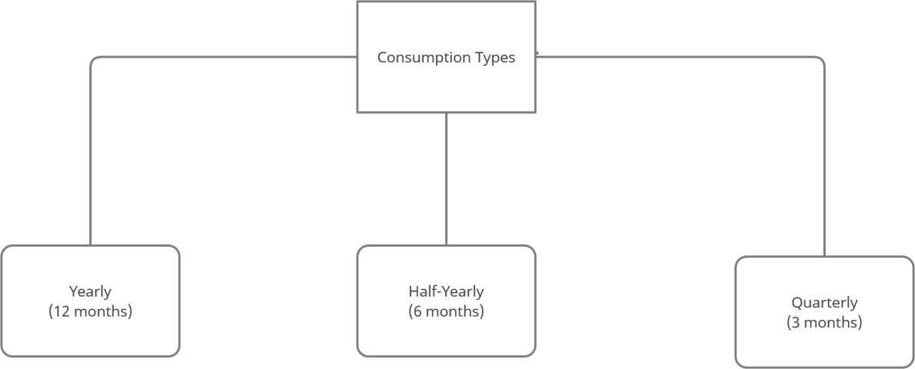

Consumption was used to find the items which were required the company most & least and in which period.

Currently, consumption can be seen for per quarter or throughout in a tabular format.

Note: For consumption calculation, business timelines are followed, starting from 1rst April & ending on 31rst March.

Expected: Represent the consumption diagrammatically.

# **Duplicate Item codes**

Items with **same description** and **different item number.**

Currently, duplicate items are calculated based on the buyer segregation. Ask if duplicate items should be calculated throughout the company instead of just departments. (Generally better if calculated across all departments w/o segregation as per my research)

Expected: Integrate Duplicate items into stocking policy.

# **Order Frequency**

Frequency was calculated on **quarterly** & **yearly.** This was done to see which quarter had max order rate. Currently, frequency is used for **stocking policy** & **cost optimization**

Expected: Check if a list of suppliers can be extracted & **visually** represented based on frequency to set up rate contract.

# **Supplier Ranking**

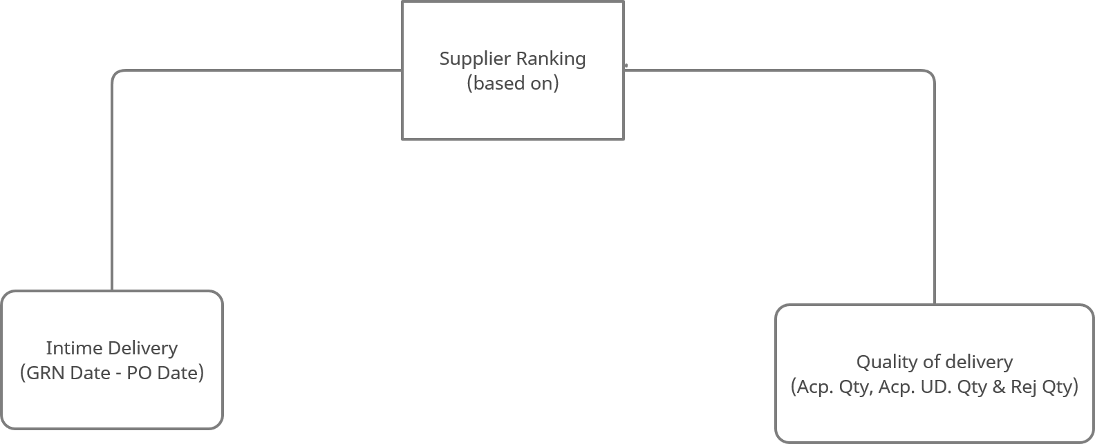

Expected: Show rankings of top 10 visually & if possible in real time.

# **Stocking Policy**

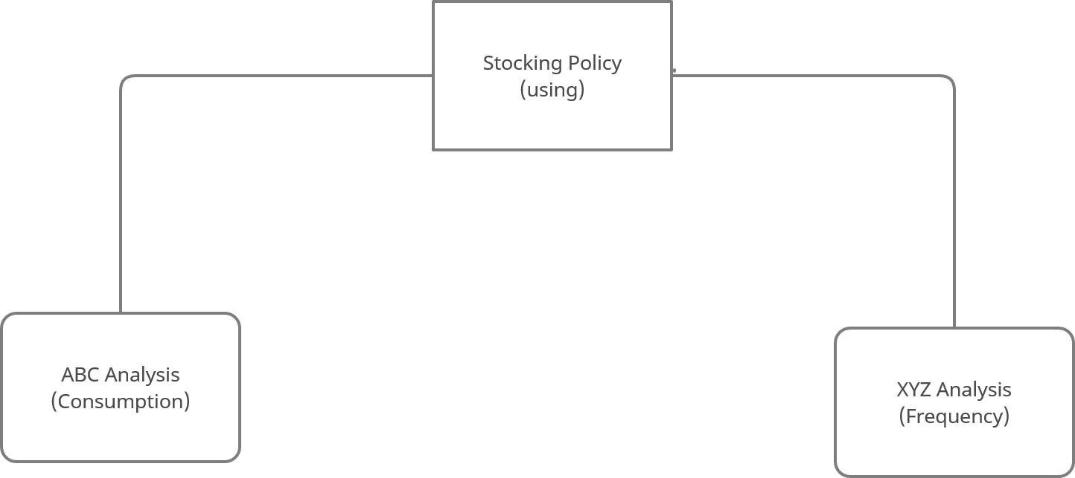

Currently, to set a stocking policy only Consumption & Frequency are being used. Hence, there may be drastic inaccuracies.

Expected: Involve as many factors as possible (eg: duplicate items, supplier rankings) while setting the stocking policy.

NOTE: **ASK FOR CARRYING COST OF ITEMS.**

# **Cost Optimization**

Cost optimization is done based on the stocking policy of that item. The amount saved per item can be calculated on a quarterly basis as well.

* 1. **Supplier Data**
  2. **Pareto graph**

Expected: Set an accurate stocking policy to get better results on cost optimization

**2.Manual for SAPpy**

## Login Page

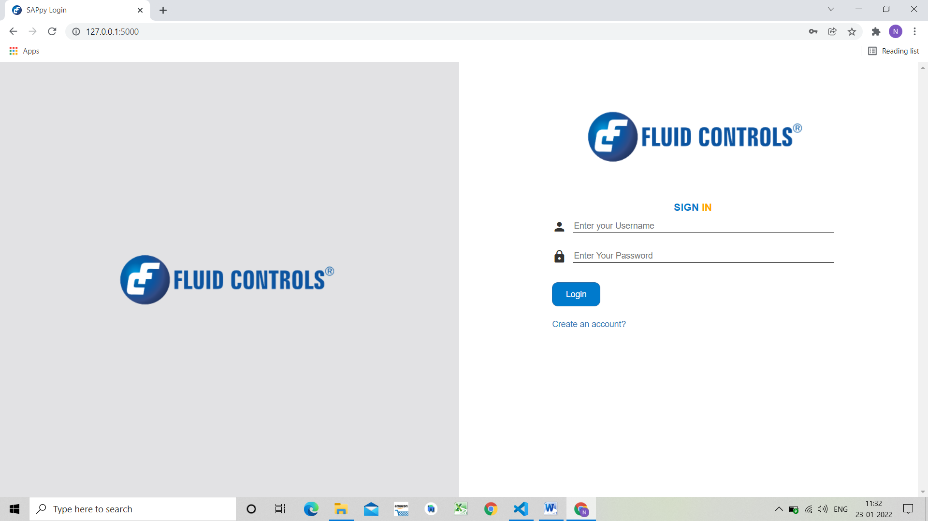

The following page is to login to ‘SAPpy’ for users having an account.

1. The user will enter the registered email id and password.
2. After entering the credentials click on login.
3. After entering correct credentials user will be taken to Homepage.
4. In case of new user, click on the link ‘Create an account?’ which will be redirected to registration page.

## Registration Page

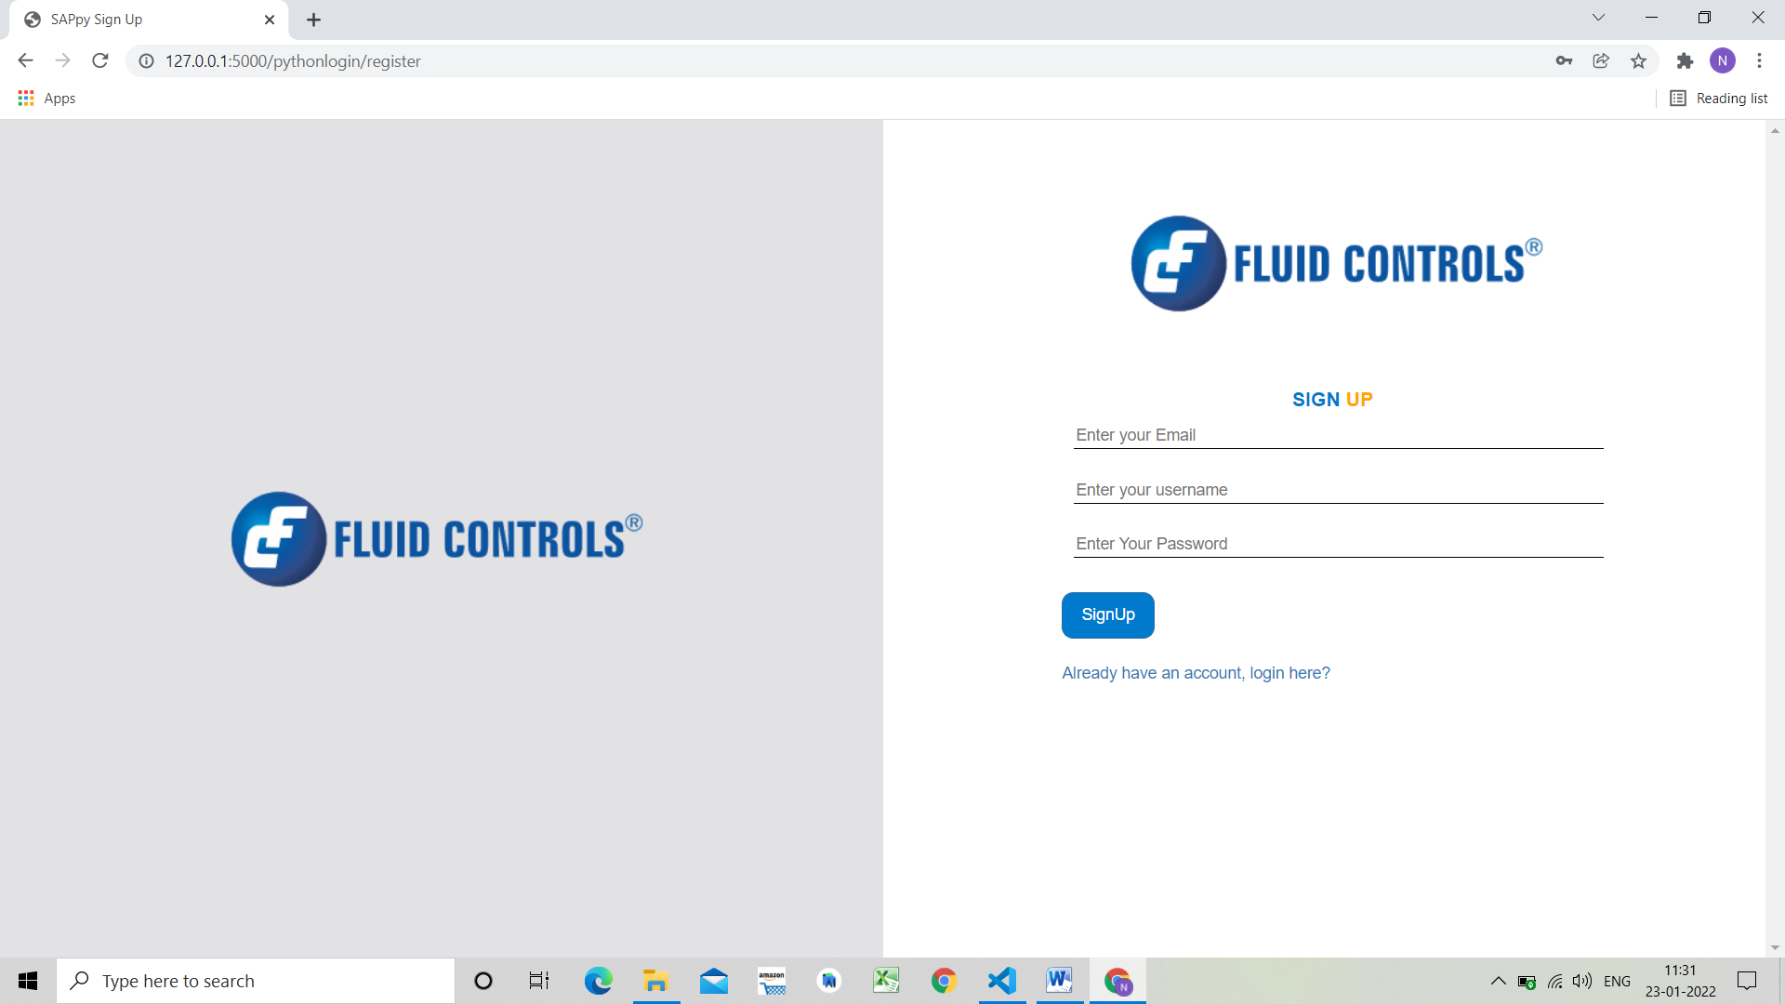

On this page we will be registering the new users.

1. Enter your email, username and password.
2. Click on the Signup button
3. On successful signup, user will be redirected to login page.

4.If user already has an account, click on the ‘Already have an account, login here?’ and

will be redirected to login page.

## Homepage of SAPpy

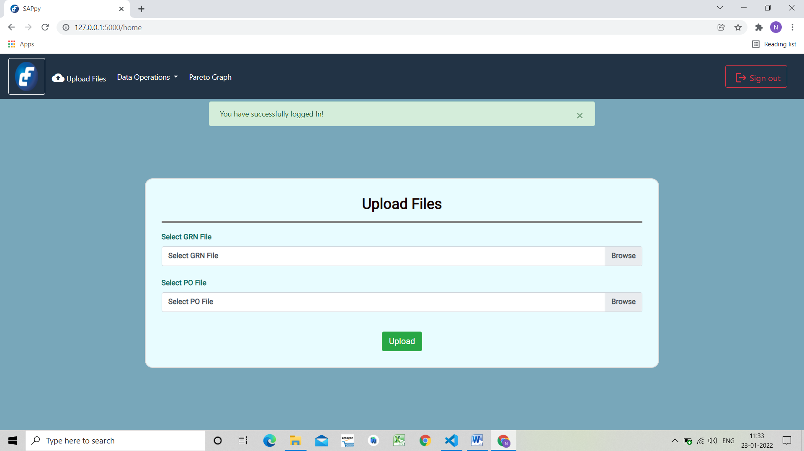

This is the homepage of SAPpy.

1.On top of window ,we have a dashboard with various options such as **upload files**,**Data Operations, Pareto Graph & Signout.**

2.In the centre of the page we have option to upload GRN sheet and PO sheet from which user would

like to see the analysis.

3.The user will browse through the system for the sheets and upload them here for further process.

## Objective 1. Consumption

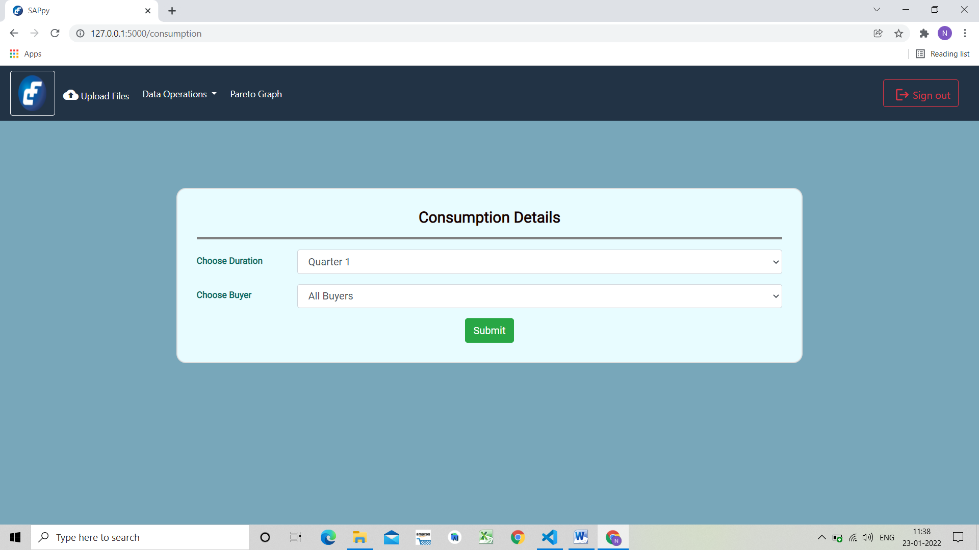

This the page where the user can view overall consumption or consumption per quarter.

1. Choose the duration from dropdown as quarter 1 or quarter 2 or quarter 3 or quarter 4 or annually.
2. Choose the buyer from the dropdown list.
3. Click upload and the user will be taken to the analysis page of results.

## Ex. Consumption for a quarter

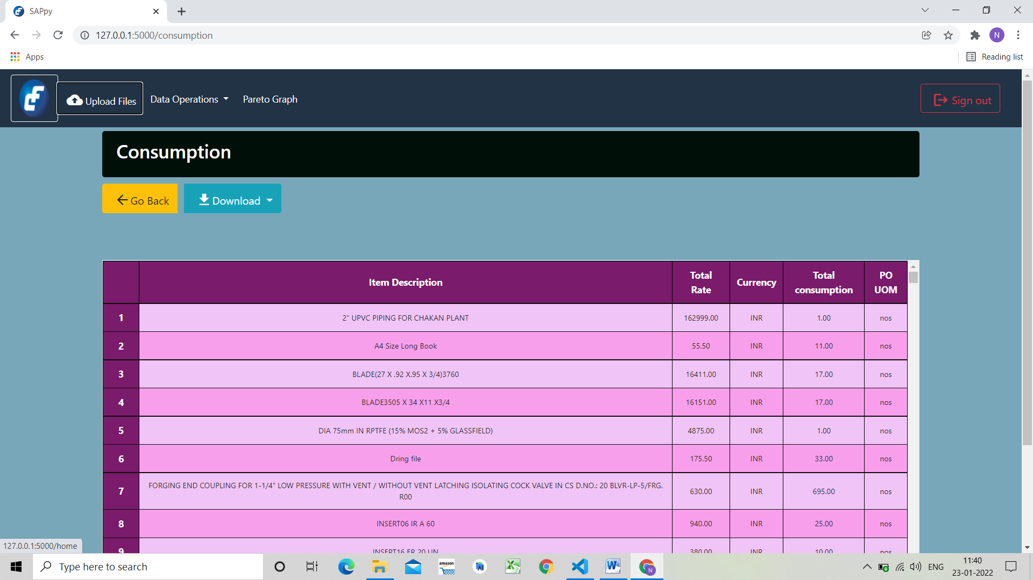

On this page the result will be displayed.

1. The first column is serial/index number of the item.
2. Second column is the name of the item i.e. description of the item
3. Third column is total rate of the item.
4. Fourth column is currency of the total rate.
5. Fifth column gives the user total consumption of the item during the selected quarter.
6. Sixth column represents unit of measure.
7. The user can download the results in .xlsx format by clicking on the Download as button.

## Ex. Overall consumption over a year

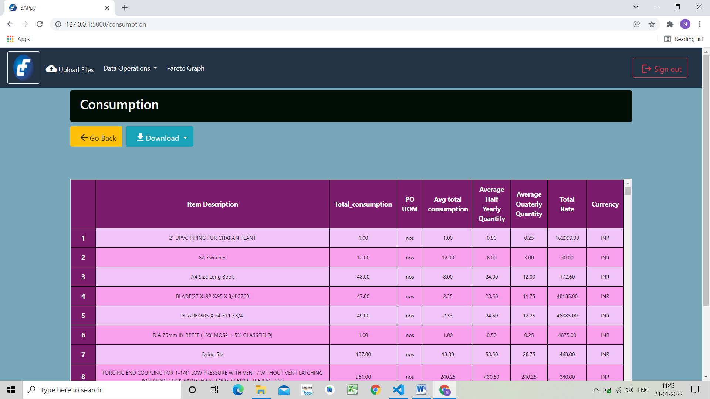

The page shows the results for consumption for a year.

1. The first column is serial/index number of the item.
2. Second column is the name of the item i.e. description of the item
3. Third column gives the user total consumption of the item for a year.
4. Fourth column represents unit of measure.
5. Next column gives the average total consumption of an item during that year.
6. Similarly the user can see Average half quarterly quantity in the next column.
7. Average quarterly quantity gives consumption of item by quarter.
8. Total rate is the rate of item for the entire year during which it is consumed.
9. Last column is currency of the total rate.
10. The user can download the results in .xlsx format by clicking on the Download as button.

## Objective 2. Duplicate item codes.

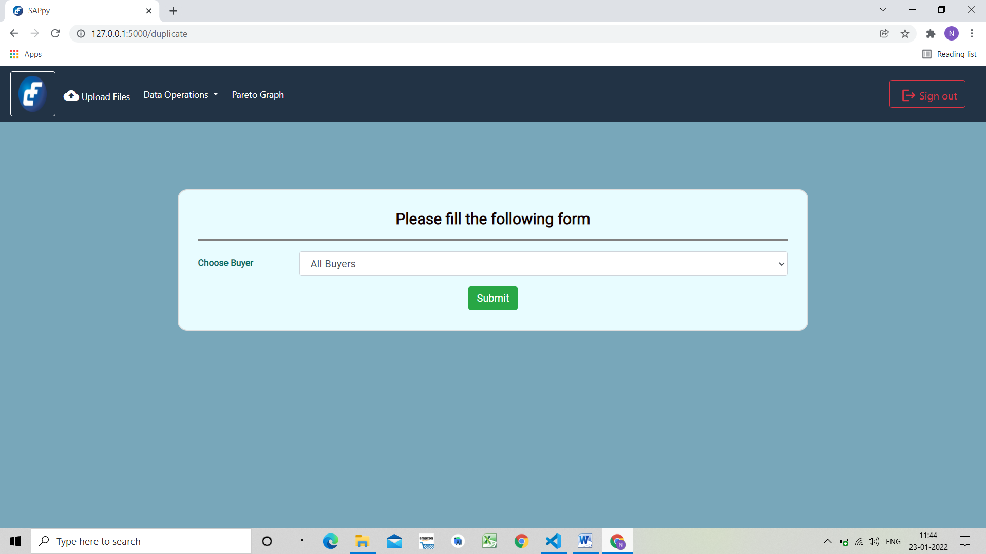

This page shows the items which have same description and different item codes.

1. Choose the Buyer from the dropdown list.
2. Click on upload.

### Ex. Duplicate Item Codes

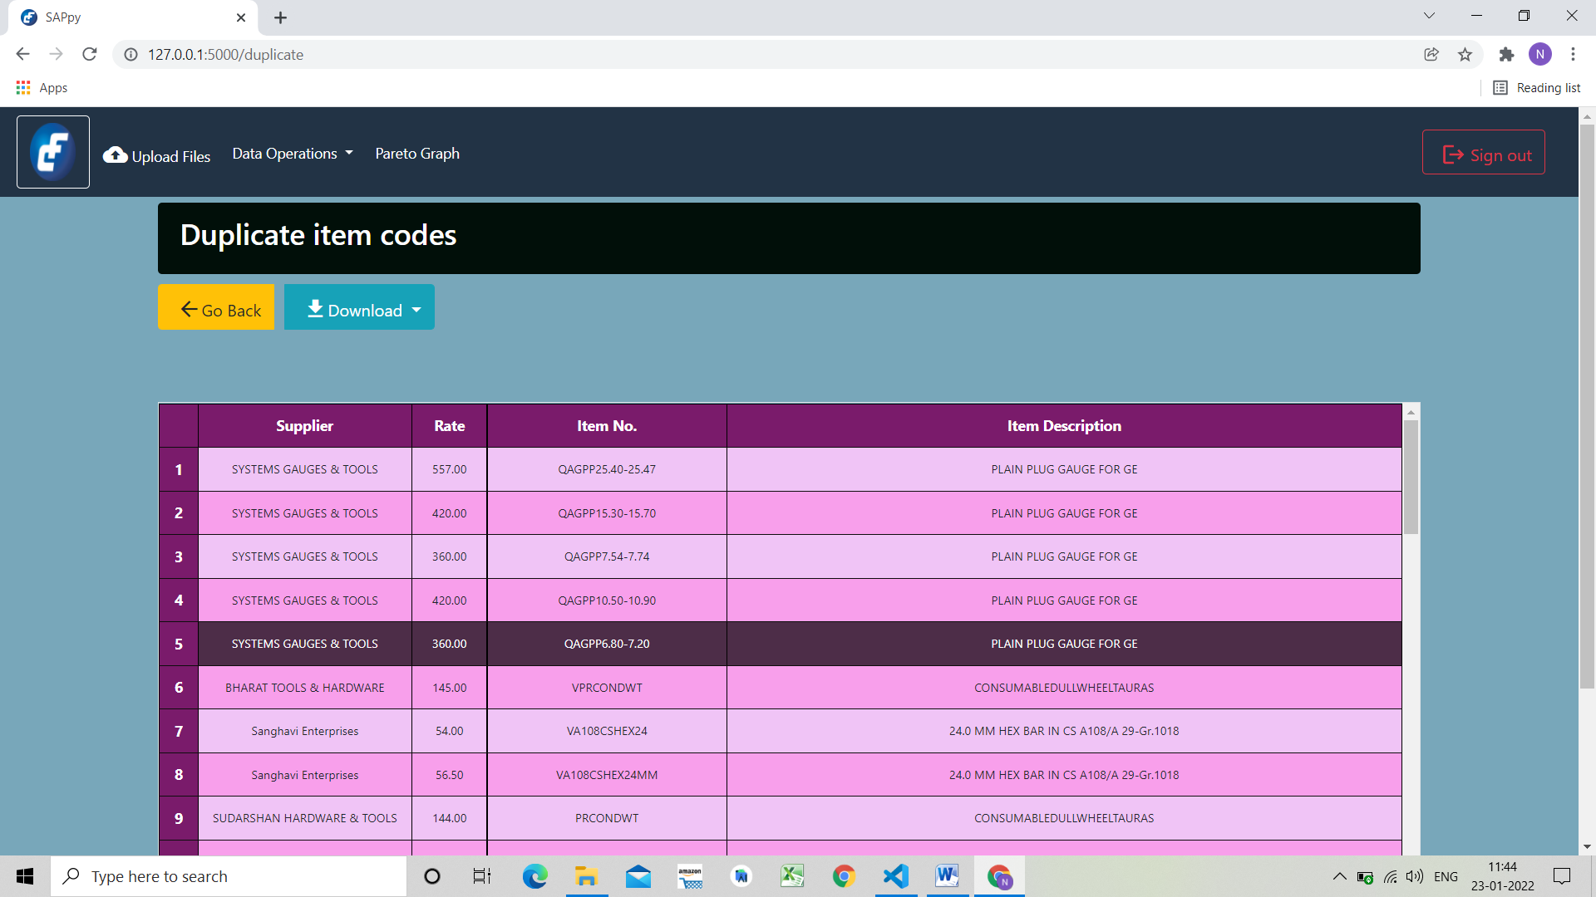

On this page user can see the results.

1. The first column is serial/index number of the item.
2. Second column is the supplier for the item
3. Rate is the rate of item by supplier
4. Item No. is the item code for the item
5. At the end, Item Description is name of the item for the given item code in previous column.
6. The user can download the results in .xlsx format by clicking on the Download as button.

Objective 3. Frequency of items ordered

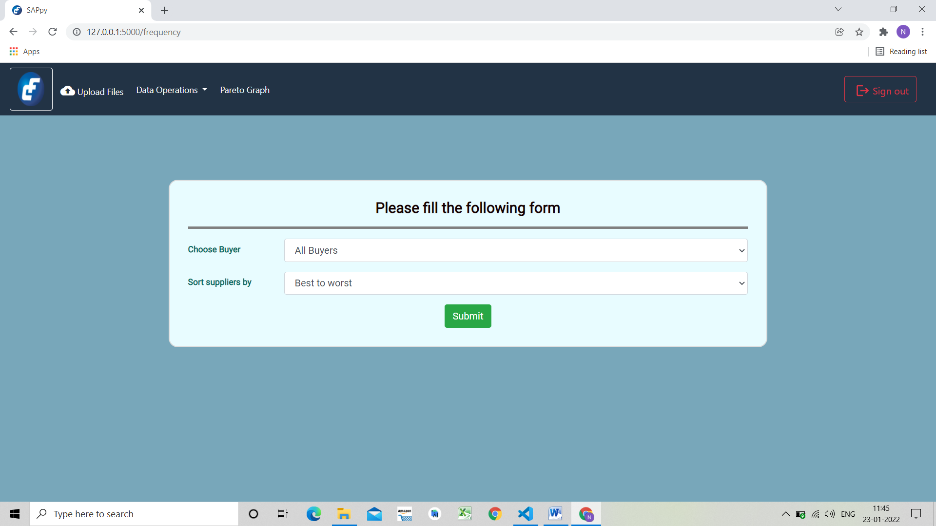

The objective here is to find frequency of items ordered with quantity of ordered item.

1. Choose the buyer from the dropdown list.
2. Select sorting for frequency, best to worst for suppliers by descending order and worst to best for supplier by ascending order.
3. Click on upload button.

## Ex. Frequency of items

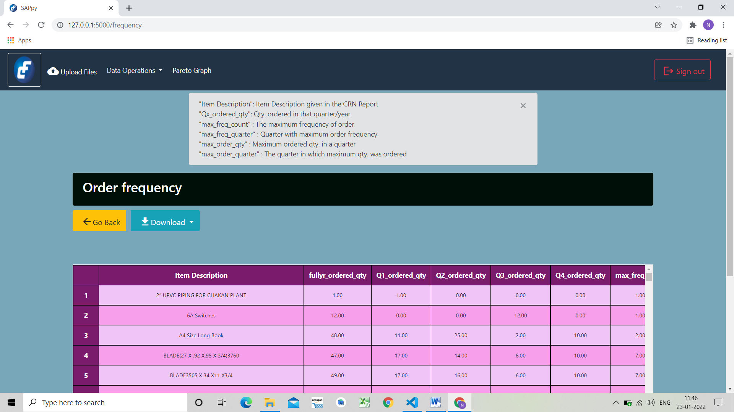

On this page user can see results for frequency of items and quantity as well.

1. In the text box user can see the description and meaning of the various columns the result table.
2. The first column is serial/index number of the item.
3. Item description is name of the item.
4. fullyr_ordered_qty is quantity of item during the entire year.
5. In next 4 columns user can see the quarters in which the items were ordered.

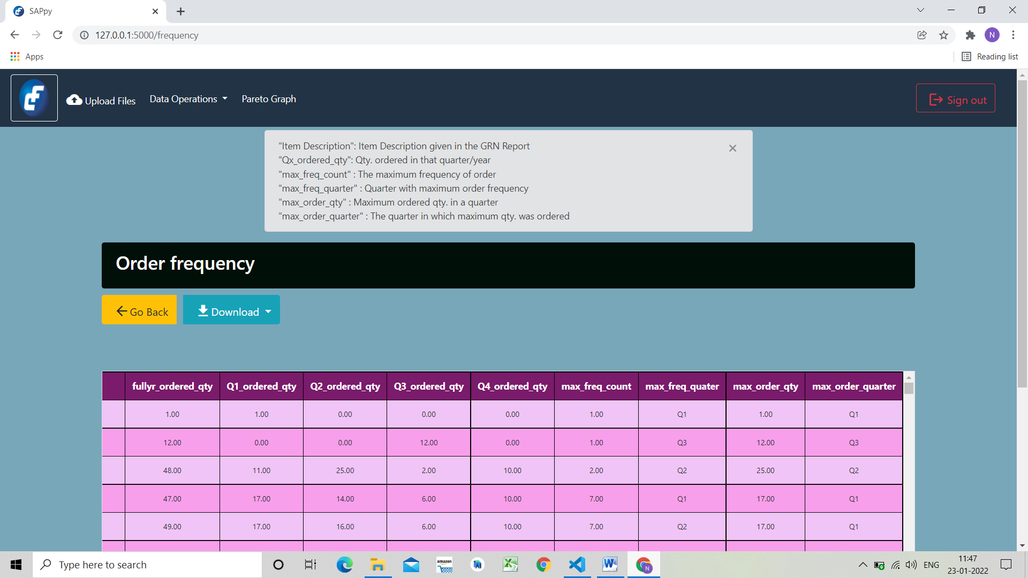

1. In max_freq_count column user can see the maximum frequency of order.
2. In max_freq_quarter user can see quarter which has maximum frequency.
3. max_order_qty is the maximum quantity of item ordered.
4. max_order_quarter is the quarter in which maximum quantity was ordered.
5. The user can download the results in .xlsx format by clicking on the Download as button.

## Objective 4. Supplier Ranking

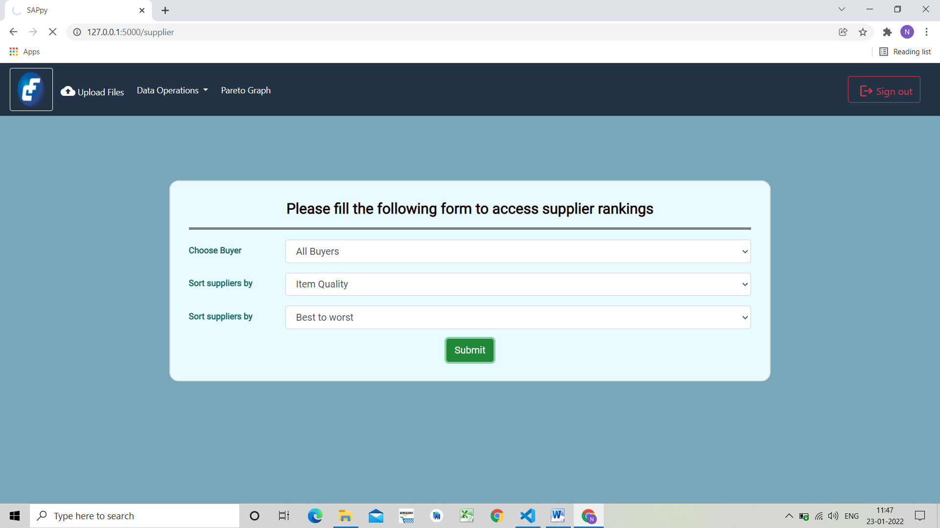

Suppliers are ranked based on their in-time deliveries & the quality of items delivered.

1. Choose the buyer from the dropdown list.
2. Select the method for sorting the suppliers i.e. by quality of item or delivery time of the items supplied by the suppliers.
3. Select sorting for supplier ranking, best to worst for suppliers by descending order and worst to best for supplier by ascending order.
4. Colour coding has been provided for supplier ranking with Green for suppliers with highest rating, yellow for moderate rating and red for poor rating.

## Ex. Supplier Ranking

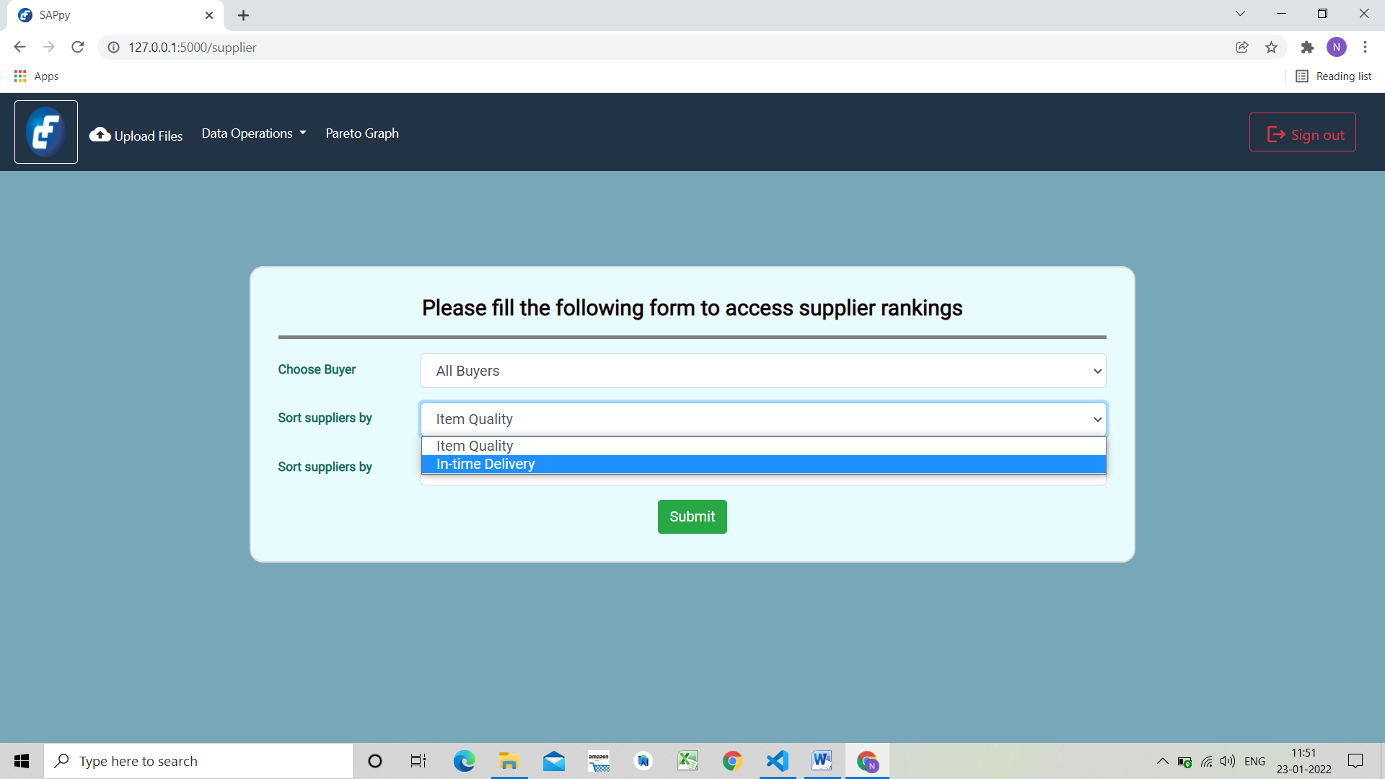

For example, in the above image we have selected buyer as Sanjay Patil and sorting by quality of items received in descending order i.e. best to worst.

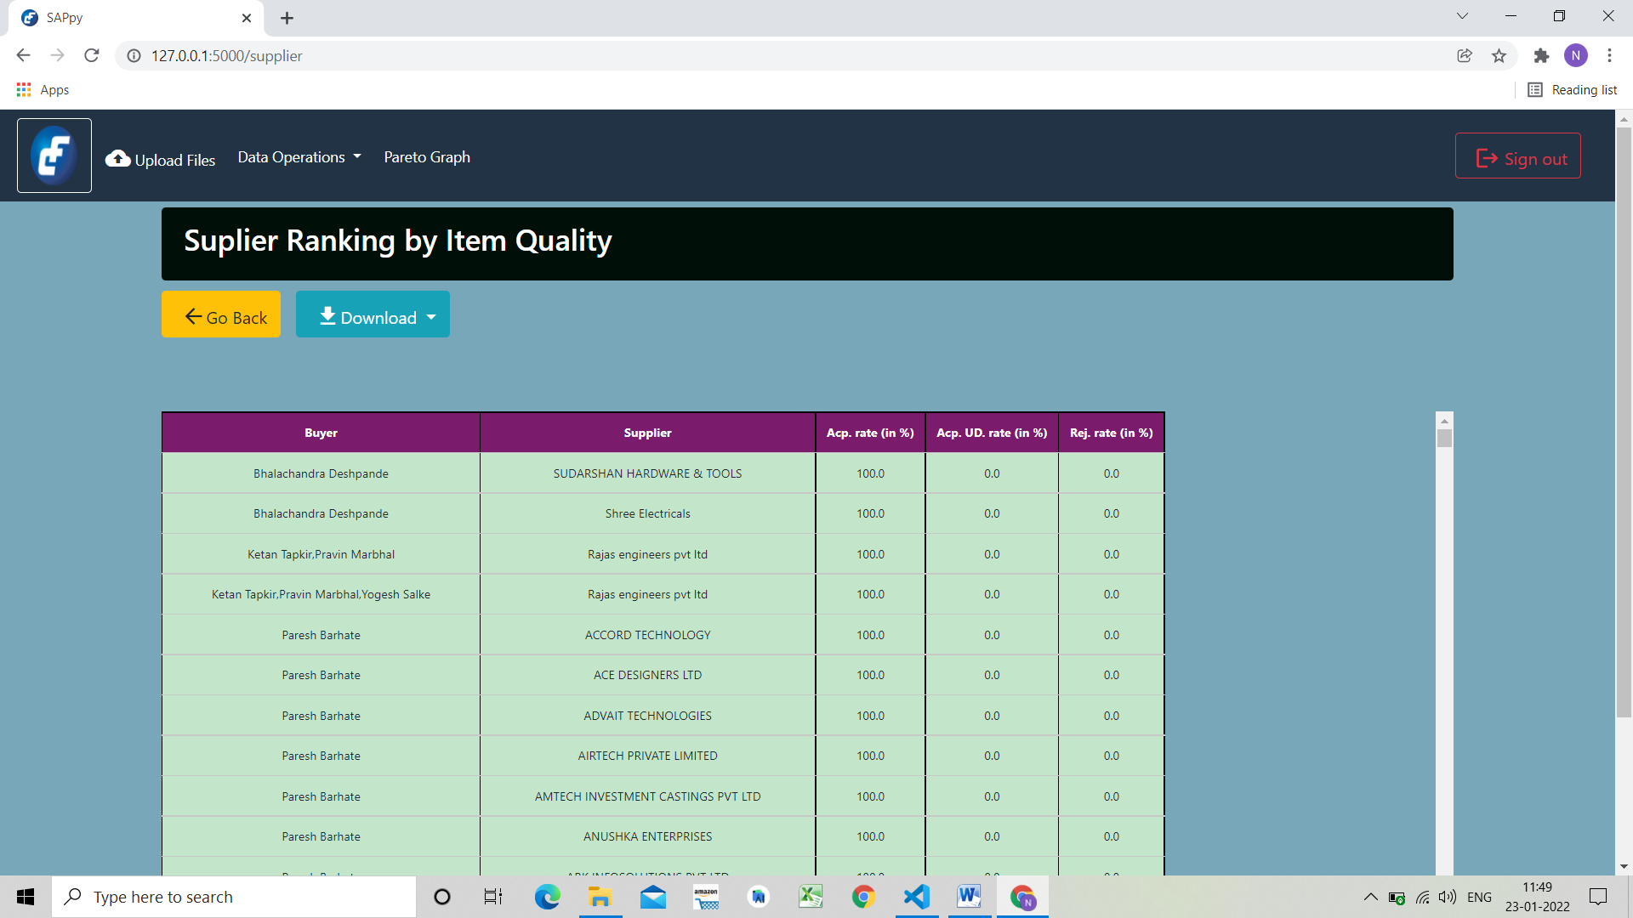

1. In the text box user can see the description and meaning of the various columns the result table.
2. Buyer columns gives details of the buyer for the item
3. Next supplier is supplier who provided that item
4. Acp.rate is percentage of acceptance of item from corresponding supplier
5. Acp.UD.rate is percentage of items received under deviation from supplier
6. Rej.rate is percentage of rate of items rejected from the supplier.
7. The user can download the results in .xlsx format by clicking on the Download as button.

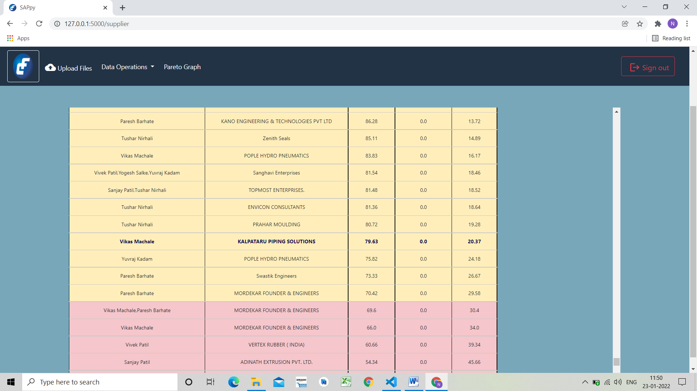

Similarly user can find supplier ranking with respect to in time delivery of items as shown in above image.

1. Supplier column gives details of suppliers for the items.
2. Buyer column gives details of the buyer for the items
3. Delayed delivery column gives user number of days by which the delivery of items was delayed by the supplier.
4. Next is frequency of orders for the item.
5. Delivery rate is percentage of item delivered by the supplier.

## Objective 5. Inventory Control (Stocking Policy)

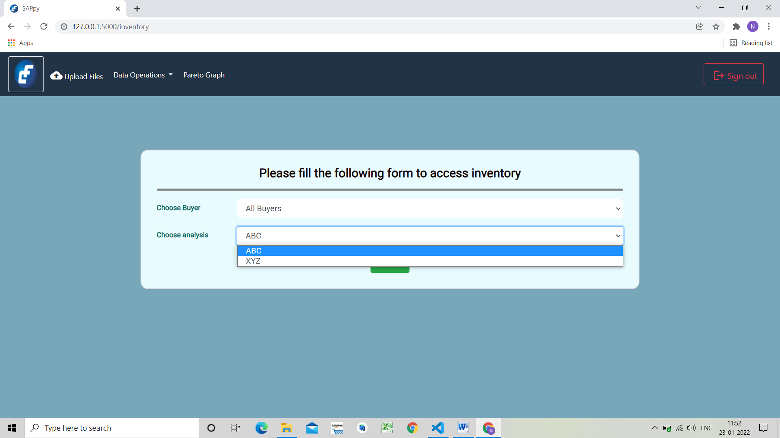

In Inventory Control the user can find the safety stock quantity, maximum stock level and reorder point which answers the how much to stock & when to stock question.

For the stocking we have provided two analysis: ABC analysis based on consumption of items and XYZ analysis based on the frequency by which items were ordered.

## ABC analysis

'A' items – 20% of the items accounts for 70% of the annual consumption value of the items 'B' items – 30% of the items accounts for 25% of the annual consumption value of the items 'C' items – 50% of the items accounts for 5% of the annual consumption value of the items

***ii. XYZ analysis***

‘X’ class - 25% of items with frequency above 75%

‘Y’ class - 35% of items with frequency between the range 75 to 40 percent range ‘Z’ class - 40% of items with frequency below 40%

Steps:

* + 1. Choose the buyer
    2. Choose the analysis from dropdown as ABC or XYZ

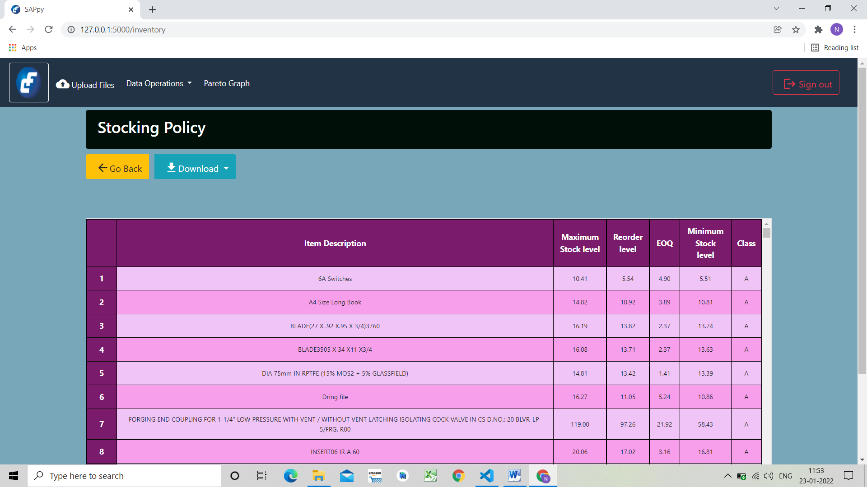

**The above image shows result for ABC Analysis of items.**

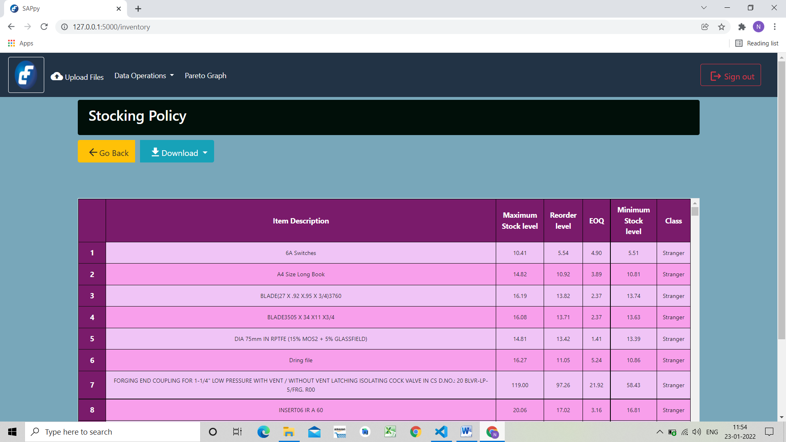

**The above image shows result for XYZ Analysis of items.**

* 1. In the text box user can see the description and meaning of the various columns the result table.
  2. The first column is serial/index number of the item.
  3. Item description is the name of the item.
  4. Maximum Stock Level is the level of maximum amount of stock in the inventory
  5. Reorder level is level at which the item should be reordered
  6. EOQ (Optimal Order Quantity) is quantity which should be ordered to keep the stock at optimal level
  7. Minimum Stock Level is the level of minimum amount of stock in the inventory
  8. Class of item gives where the items falls according to the analysis used i.e. ABC or XYZ.
  9. The user can download the results in .xlsx format by clicking on the Download as button.

## Objective 6: Cost Optimization

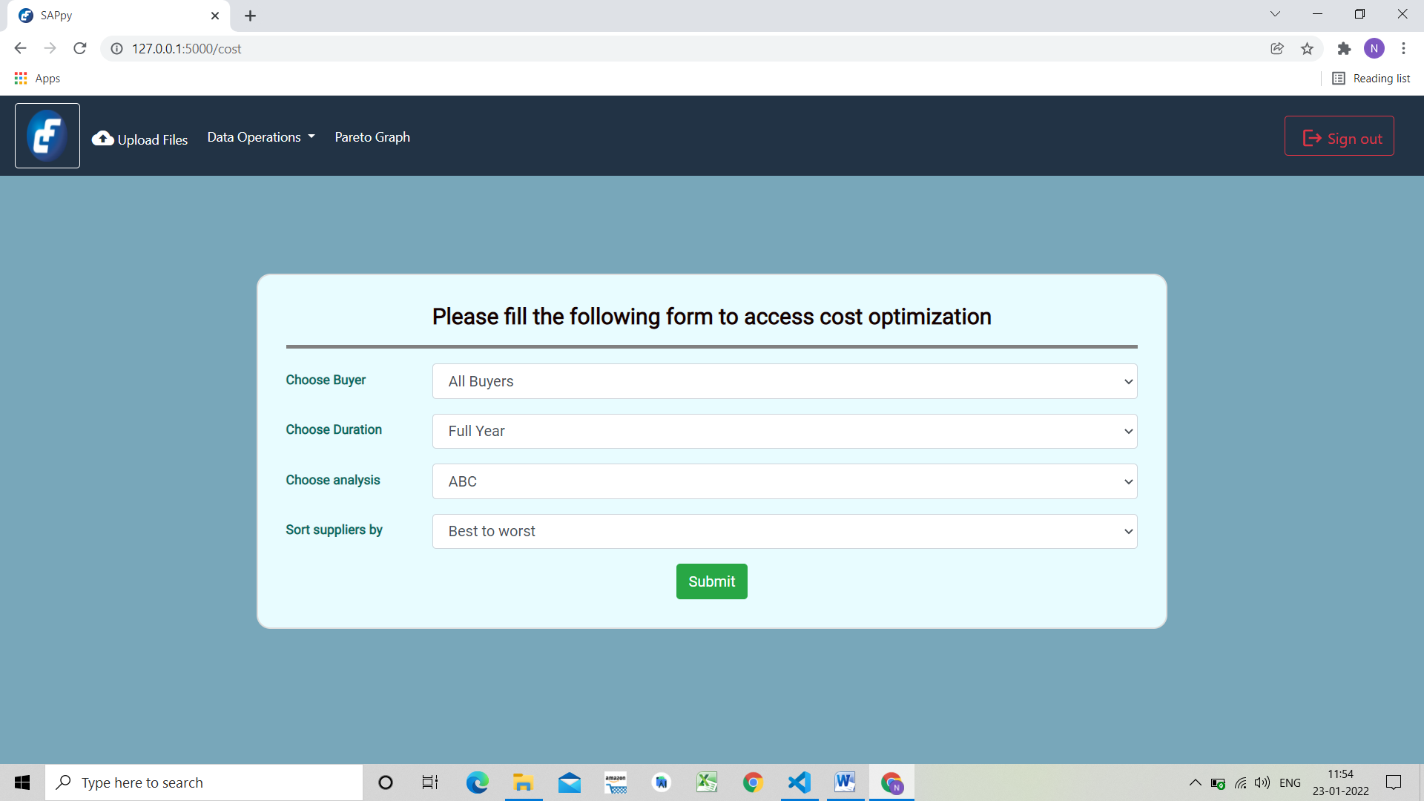

Based on the stocking policy in the inventory section & the supplier ranking, SAPpy estimates the total cost saved as well as answers when to stock the items.

1. Choose the buyer from dropdown list.
2. Choose duration from dropdown list.
3. Choose the analysis
4. Select sorting for suppliers, best to worst for suppliers by descending order and worst to best for supplier by ascending order
5. The user can also see the rankings of the supplier if needed.
6. Click on upload.

### Ex. Cost Optimization

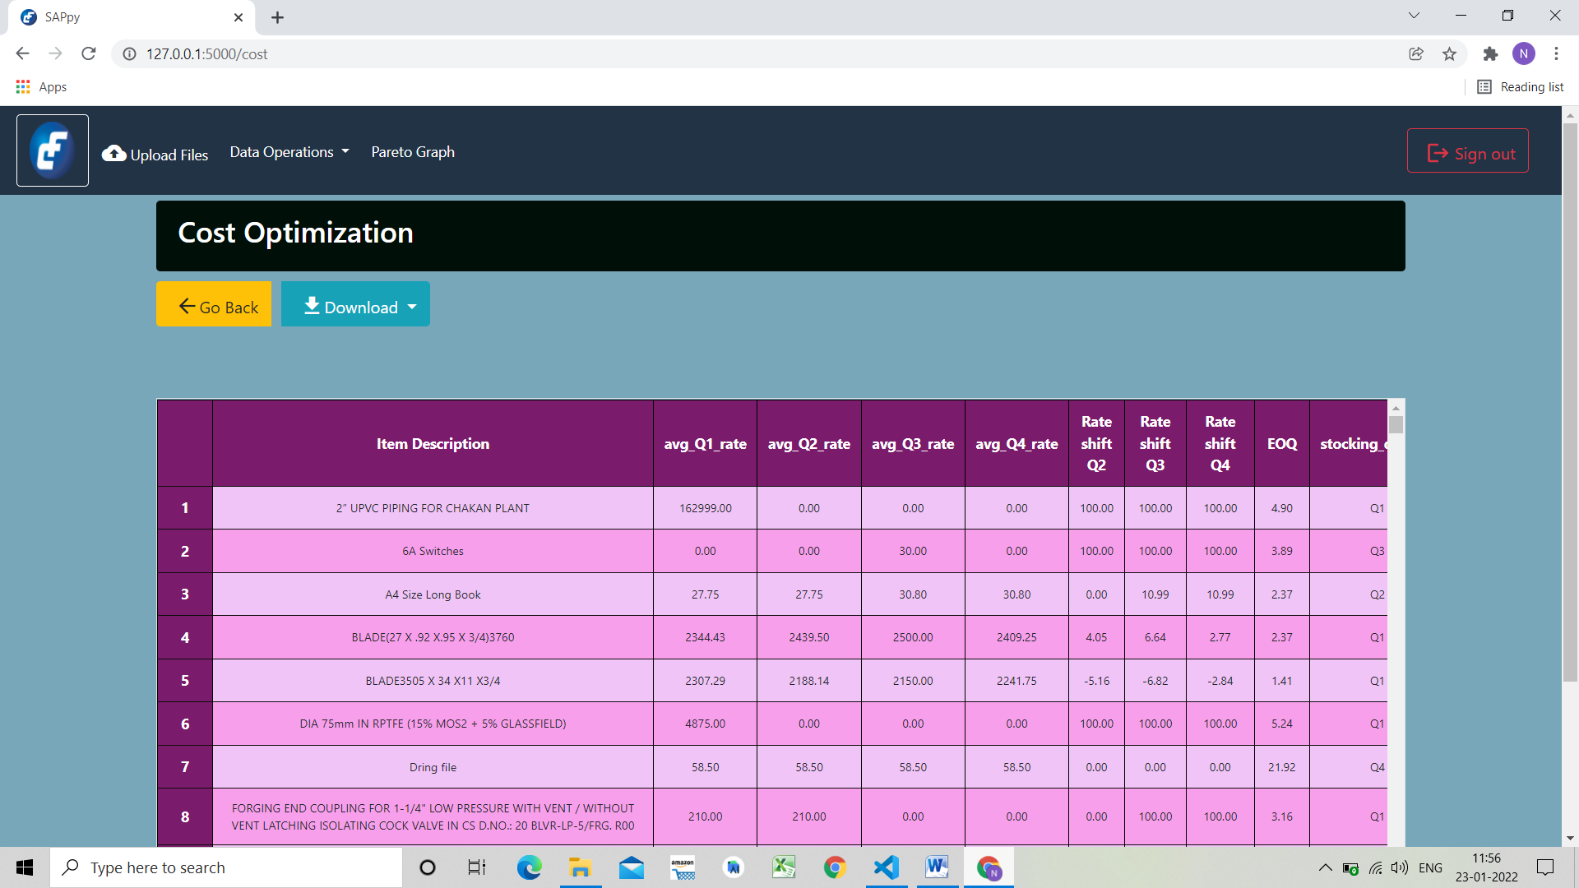

1. The first column is serial/index number of the item
2. Item description is the name of the item.
3. Columns avg_Q1_rate, avg_Q2_rate, avg_Q3_rate and avg_Q4_rate represent the rate of item in the particular quarter.
4. Next 3 columns, Rate shift Q2 Rate shift Q3 and Rate shift Q4, give the shift in rate of item with respect to previous quarter. For example. Q2 with respect to Q1.

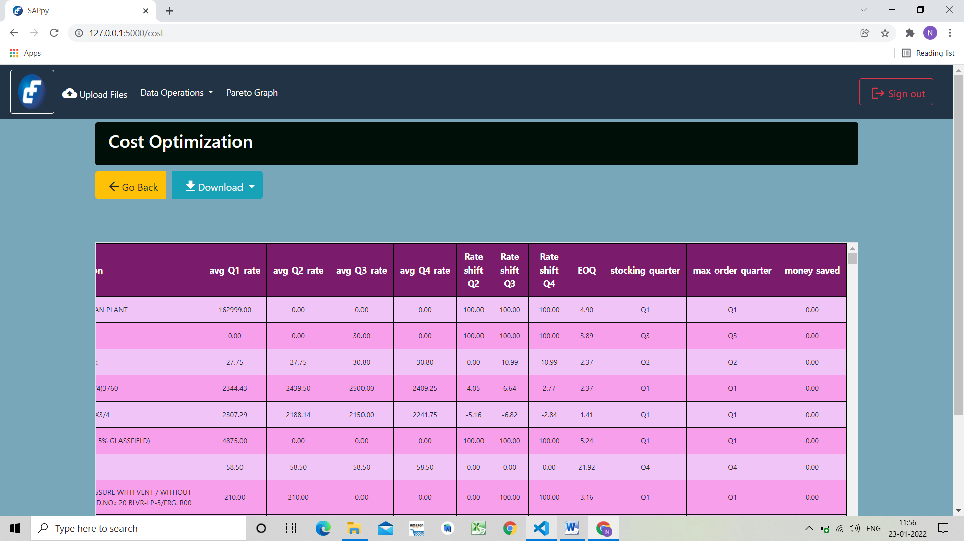

1. EOQ (Optimal Order Quantity) is quantity which should be ordered to keep the stock at optimal level
2. stocking_quarter gives the quarter which would be profitable to stock a particular item.
3. max_order_quarter gives the quarter in which maximum quantity was ordered.
4. money_saved gives the amount which would be saved if an item is stocked according to the stocking_quarter.
5. The user can download the results in .xlsx format by clicking on the Download as button.

## Objective 7: Supplier Data

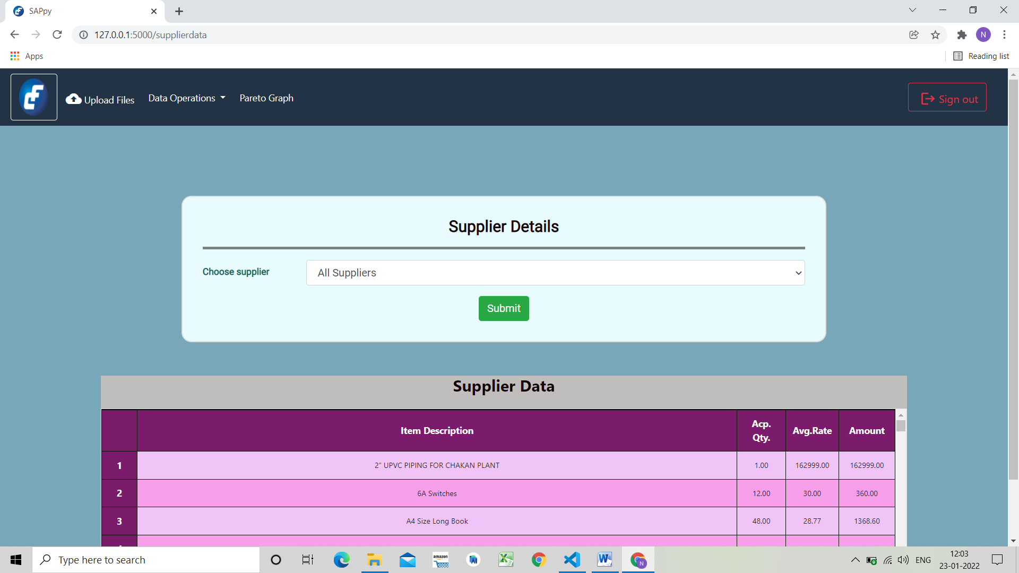

Based on the supplier Data in the inventory section, SAPpy estimates total amount of particular item purchased by particular Supplier and Average rate of Supplier Items for all year.

1. Choose the Supplier from dropdown list of Supplier.
2. Click on Submit.

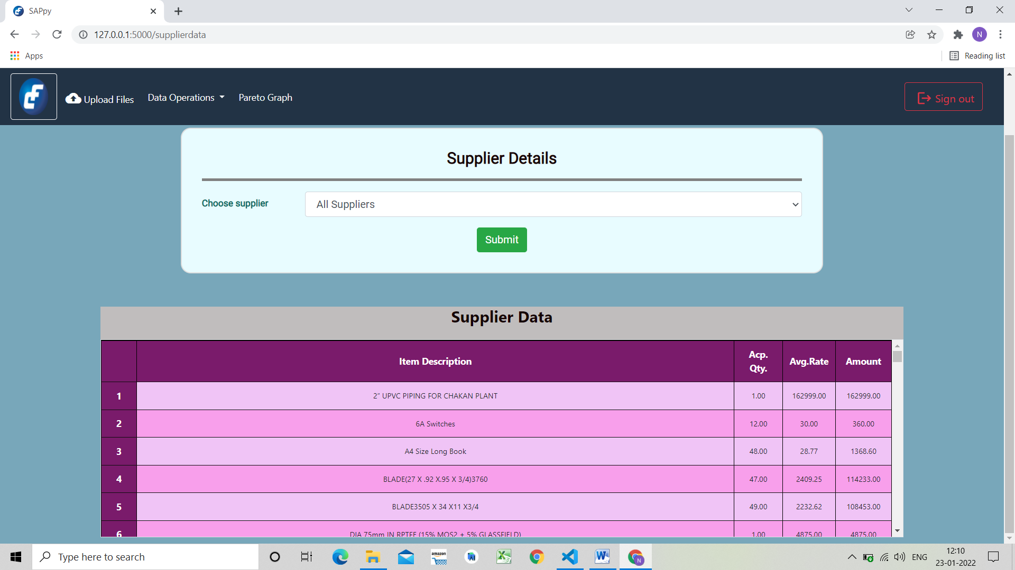

1. In the text box user can see the description and meaning of the various columns the result table.
2. The first column is serial/index number of the item.
3. The second column is Item description is the name of the item
4. The Third column is Accepted Quantity.
5. Forth column is Average Rate for Each Item from all year.
6. Total amount spend on Item.

## Objective 8: Pareto graph

